**Project 5: Cyclist Data Project Report**

**Data Management Final Project**



**Prepared by: Group 9**

Eloise Chen

Yanjing Li

Michael Suzuki

Yigong Yuan

Yudong Zhang

# Table of Contents

Executive Summary 2

Project Statement 2

Data Dictionary 3

Dimensional Modeling + ERD 3

1. Business and event processes 3

2. Grain 3

3. Facts and dimensions 3

4. ERD Diagram (Star Schema) 7

Data Transformation 7

Loading Data 7

Data Cleaning 8

Rides above 1500 Minutes 8

Populating Dimension and Fact Table 8

KPIs, Visualizations, and Insights 9

KPI 1: Ride Duration 10

KPI 2: The Most Common Rideable Type 11

KPI 3: Most Frequent Route 12

KPI 4: Max Bike Usage 13

KPI 5: Casual-Member Rate 14

Data Visualization: 16

Tableau Dashboards 16

Recommendations 20

Project Challenges 21

Technical Challenges 21

KPI Calculations Challenges 21

Further Research 21

Market Trend Research 22

Appendix 23

# Executive Summary

The Cyclist Data Project by Group 9 focused on analyzing historical Divvy/Lyft bike trip data from 2021 in the Chicago area. The project aimed to provide strategic insights by examining ride duration, ride length, and user segmentation. A significant portion of the work involved data cleaning due to issues like missing station names, IDs, and geographical coordinates, resulting in the exclusion of rides with null values. This process reduced the original dataset size significantly. The team also decided to omit rides above 1500 minutes, considering them outliers. This comprehensive approach allowed the team to analyze the data through various lenses, including temporal, segmentation, and geographical perspectives, providing a nuanced understanding of the cycling trends in Chicago.

The project's methodology revolved around dimensional modeling, using a star schema ERD to organize data into six dimensions: User Type, Rideable Type, Trip Time, Time of Day, Location, and Date. This structuring was essential for examining five key performance indicators (KPIs): Ride Duration, Most Common Rideable Type, Most Frequented Route, Maximum Bike Usage, and Casual-Member Rate. These KPIs provided insights into aspects such as customer engagement, satisfaction, and demographic preferences. For instance, the analysis of Ride Duration revealed patterns like peak average ride durations in May, longer rides on weekends, and different usage patterns between casual and member users. These findings were crucial for strategic decisions regarding pricing, marketing, and operational strategies.

The project encountered several challenges, particularly in data integrity and processing. The raw dataset presented issues with missing values and precision in geographic coordinates. Additionally, the complexity of defining the "docked bike" category and its impact on average trip duration presented challenges in KPI calculations. Despite these hurdles, the team managed to produce insightful analyses, with recommendations for future strategic decisions. Their work underscored the importance of adapting strategies to evolving market trends and highlighted the potential for Divvy to optimize resource management, marketing plans, and pricing strategies in response to changing demand patterns.

# Project Statement

The project aims to analyze the historical Divvy/Lyft bike trip data from 2021 in the Chicago area. By analyzing ride duration, and ride length and segmenting users, the team provides findings for aiding strategic decisions.

# Data Dictionary

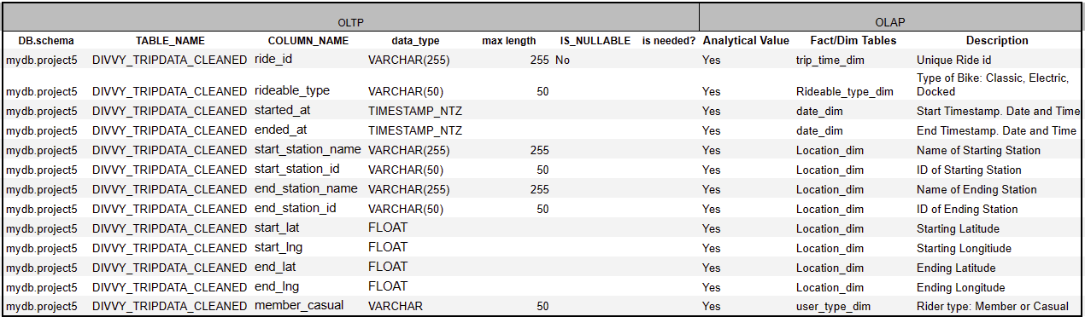

# Dimensional Modeling + ERD

## Business and event processes

The business process is a bike rental service. This involves customers/riders of different membership types (member or casual) renting a bike (electronic, classic, docked). Each customer picks up a bike at a start station, uses the bike, and returns it to an end station. The event process involves the time and location of each bike ride trip, the types of customers, and the types of rideable bikes.

## Grain

It is crucial to determine the grain of the fact table for dimensional modeling. The grain refers to the granularity level of information each row in the fact table contains. In this analysis, the grain is defined as an individual bike ride record. Each row in the fact table represents a unique ride from start to end, with information about the start and end time, the start and end stations, the type of bike used, and the type of user.

## Facts and dimensions

Using the 7W’s framework, we defined 6 dimensions as below:

|  |  |  |  |
| --- | --- | --- | --- |
| **Dimensions** | | | |
| **7Ws** | **Dimensions** | **Table Name** | **Attributes** |
| **Who** | User Type Dimension | user_type_dim | 1. user_type_key 2. user_type |
| **What** | Rideable Type Dimension | rideable_type_dim | 1. rideable_type_key 2. rideable_type |
| **When** | Trip Time Dimension | trip_time_dim | 1. ride_key 2. ride_id 3. started_at 4. Ended_at |
|  | Time Dimension | date_dim | 1. date_key 2. month_name 3. month_num 4. year 5. quarter 6. week_name (weekday or weekend) 7. week_num 8. day_of_week |
|  | Time of Day Dimension | time_of_day_dim | 1. time_of_day_key 2. hour 3. am_pm 4. hour_24 |
| **Where** | Location Dimension | location_dim | 1. station_key 2. station_id 3. station_name 4. station_max_lat 5. station_min_lat 6. station_max_lng 7. station_min_lng |
| **Why** | Not relevant to this dataset | | |
| **How** | Not relevant to this dataset | | |

Based on the 5 major KPIs and the defined Dimensions, we defined the fact table as below:

|  |  |  |
| --- | --- | --- |
| **Fact** | | |
| **Table Name** | **Attributes** | **Definitions** |
| trip_fact_table | 1. ride_id 2. start_date_key 3. end_date_key 4. start_timeofday_key 5. end_timeofday_key 6. start_station_key 7. end_station_key 8. rideable_type_key 9. user_type_key 10. ride_count 11. ride_duration | * ride_id: the unique identifier of each bike ride record for each row * keys attributes: foreign keys used to link to different dimension tables   + start/end date keys: date_dim   + start/end time of day keys: time_of_day_dim   + start/end station keys: location_dim   + rideable type key: rideable_type_dim   + user_type_key: user_type_dim * ride_count: count of the ride, counting 1 ride for each row * ride_duration: timespan of each ride trip in minutes |

|  |  |  |  |
| --- | --- | --- | --- |
| **Dimensions** | | | |
| **7Ws** | **Table Name** | **Attributes** | **Why the Measures?** |
| **Who** | user_type_dim | user_type_key  user_type | * KPI: Casual-Member Rate * Discover the difference in patterns of member vs. casual users |
| **What** | rideable_type_dim | rideable_type_key  rideable_type | * KPI: Most Common Rideable Type * Discover the most common type of bikes for transportation |
| **When** | trip_time_dim | ride_key  ride_id  started_at  ended_at | * Relates to all 5 KPIs * Three dimensions to find out the time attributes of the trip because time can be looked at in many ways * Discover how trips differ within different timespans (e.g. weekdays vs. weekends; morning vs. afternoon vs. night) * Discover the lengths of trips in different situations, specifically by using “trip_time_dim”, which includes starting and ending timestamps of each ride |
|  | date_dim | date_key  month_name  month_num  year  quarter  week_name  week_num  day_of_week |
|  | time_of_day_dim | time_of_day_key  hour  am_pm  hour_24 |
| **Where** | location_dim | station_key  station_id  station_name  station_max_lat  station_min_lat  station_max_lng  station_min_lng | * KPI: Most Frequented Route * Discover optimal bike deployment and collection points * Each unique combination of ID and name accounts for one row due to the many-to-many relationship between the two variables * Each station has a range of coordinates split into four attributes: max/min latitudes and longitudes |

## ERD Diagram (Star Schema)

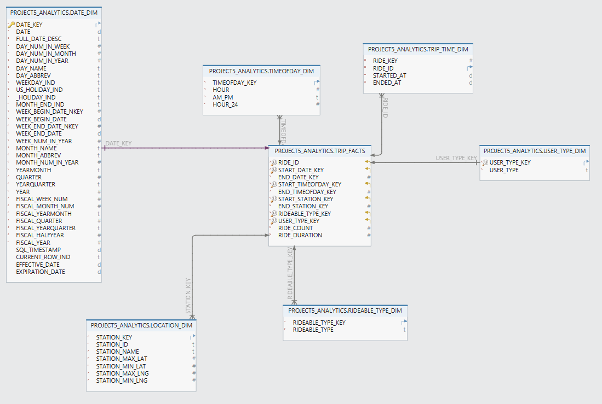

# Data Transformation

## Loading Data

Our team created the raw data table, divvy_tripdata, in Snowflake and uploaded the 12 files into the table. From there, the team cleaned the data to remove rides with null values and moved the data to the DIVVY_TRIPDATA_CLEANED table.

Our team managed to load the data through two different approaches: loading them directly to Snowflake and copying them into Snowflake through AWS.

After creating the raw data table and setting the data type correctly, we went over to the Database tab in Snowflake and uploaded the data using the “Load Data” button. We simply dragged and dropped the data files downloaded from Divvy and all data are uploaded with no glitch. However, we did notice that this operation utilized a large amount of processing power, which could be costly for large corporate clients loading big data on a regular basis.

## Data Cleaning

Our team analyzed the data and found significant missing information. Many station names, IDs, and geographical coordinates (starting and ending longitudes and latitudes) were absent. Additionally, some latitude and longitude data were only accurate to two decimal places, inadequate for reliably linking station names and IDs to specific locations. To ensure high-quality data, we removed all rows containing null values. This process resulted in a reduction of the dataset from the original 5,595,063 rows to 4,588,302 rows, amounting to a 17.99% deletion of the original data.

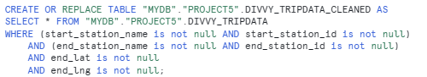

## Rides above 1500 Minutes

When looking at average and max ride duration, the team noticed outliers over 50,000 minutes. Bike rentals are supposed to be at the daily level and the max standard bike ride duration was 1,500 minutes so the team decided to exclude rides above 1,500 minutes in duration as outliers due to poor data. This was 1,167 rides from the 4,588,302.

## Populating Dimension and Fact Table

After removing nulls from the raw data, we created a new schema, “project5_analytics”, to store dimension and fact tables.

Constructing dimension tables, user_type_dim, rideable_type_dim, and trip_time_dim, was straightforward. The process involved creating the tables and specifying each variable and its data type, setting up sequences for key generations, and populating the tables with corresponding variables from the cleaned dataset.

One specification is around location_dim. The raw data contains overlapping start and end stations because start stations can also be end stations, and vice versa. We also recognized that station IDs and names are not unique identifiers of stations, with their many-to-many relationship, and are associated with multiple geographic coordinates. Therefore, we merged all station data using the UNION ALL command to capture the full extent of station names, IDs, latitudes, and longitudes. Then, by wrapping the combined station information into a subquery, we aggregated the maximum and minimum latitude and longitude values for each unique station ID and name combination. This approach allowed us to form a holistic list of stations that accurately incorporates the range of coordinates associated with each station, grouping them by their IDs and names. The code is shown below:

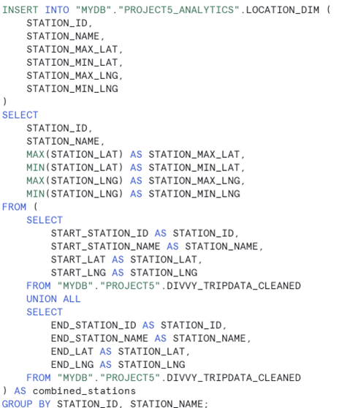

Constructing the fact table followed a similar process to the dimension tables, with the exception that data selection was based on joining different dimension tables on ride_id. For calculated fields, each row was assigned a ride_count of 1, allowing us to easily sum up the number of rides for future KPI establishments. In addition, ride_duration was calculated by joining the trip_time_dim table and applying the TIMEDIFF command to compute the time difference between the ride's start and end times in minutes, simplifying future analysis and dashboarding.

# KPIs, Visualizations, and Insights

In this project, our team has developed five key performance indicators – ride duration, most common rideable type, most frequent route, max bike usage, and casual member rate, to analyze the trend in the cyclist data. Our analysis comes from three perspectives: temporal analysis, segmentation, and geographical analysis, which measures performance from a comprehensive view.

## KPI 1: Ride Duration

The ride duration metric quantifies the duration of each ride, deriving from the difference between each trip's start and end times. This indicator is instrumental in assessing levels of customer engagement and satisfaction. It provides critical insights necessary for refining pricing strategies, enhancing customer experience, and contributing positively to the company's financial outcomes.

Our analysis encompasses the following key aspects:

1. Temporal Analysis: Examines the average and maximum ride durations (in minutes) overall, alongside average durations analyzed for each month in 2021. It also differentiates between average ride durations on different days in a week, and hourly analysis based on the ride's start time.
2. Segmentation: Breaks down average ride durations by user type and rideable type, providing a nuanced view of usage patterns.
3. Geographical Analysis: Focuses on the average ride duration associated with each start station, offering a spatial perspective on ride durations.

The analysis provides the management team with insights into seasonality trends, and demographic preferences.

1. Seasonality and Trends: The data highlights a peak in average ride durations in May, with a noticeable decline from October to January, indicating significant seasonality effects.
2. Weekday Versus Weekend Usage: Rides are significantly longer on weekends than on weekdays, suggesting variations in ride purposes and user availability.
3. Hourly Trends: Early morning rides (5 am to 8 am) are shorter in duration, potentially reflecting commuter patterns.
4. Behavioral Differences by User Types: Casual users tend to have ridden more than double the length of those by members, indicating different usage patterns between the two groups.
5. Rideable Type Preferences: Classic bikes show a slightly longer ride duration, on average, over electric bikes in terms of ride duration.

Those insights are crucial in driving strategic management decisions on pricing, marketing, and operational strategies, which further optimizes resources and enhances long-term customer value for better financial outcomes.

1. Pricing strategies: The seasonal, daily, and hourly demand fluctuations suggest Divvy implement a dynamic pricing system. Divvy could increase the unit price during peak time/season and offer discounts for off-peak times. Further studies on price-demand elasticities are needed to determine the specific price settings.
2. Marketing plans: Considering a lower average trip duration for members, the company needs to focus on improving customers’ perceived values by adding services and benefits to the member user group and encouraging longer rides.
3. Operational enhancements: Divvy needs to design its operational systems based on the demand level. They need to create an inventory management system, ensuring sufficient demand for bikes during peak season/days/hours, as well as stations with high demands. In addition, Divvy should schedule maintenance activities during periods of low activity to minimize disruptions and ensure seamless operations.

## KPI 2: The Most Common Rideable Type

This key performance indicator offers valuable insights into pinpointing demand hotspots, which guides strategic directions for potential partnerships with local businesses or government entities. Such insights are essential in determining marketing priorities and customizing services to be more user-centric, enhancing overall customer engagement and satisfaction.

Our analysis is structured into three major perspectives:

1. Temporal Analysis: Identifies the most popular rideable types across time frames, analyzing trends across months in a year, days in a week, and hours in a day.
2. Segmentation: Explores preferences by user type (casual vs. members) and by rideable types. Informing decision-makers with targeted data.
3. Geographical Analysis: Assesses preferred rideable types at each station, guiding an overview of preference distribution patterns.

The analysis provides insights into the seasonality trends and geographical differences in the most popular rideable type.

1. Seasonality and Trends: Despite the lower number of used frequencies during winter months, classic bikes are always the most popular rideable. Its popularity consistently outperforms electric bikes, regardless of the time frame and user type (casual vs. members).
2. Geographical Differences: Rideable-type popularities vary across stations. Despite a majority of preference for classic bikes, some stations do have a higher popularity for electric bikes.

Those insights provide critical strategic information on resource allocation, product development, and marketing planning.

1. Inventory Management and Resource Allocation: Given the consistent popularity of classic bikes over time, it is critical to implement an inventory management system that ensures sufficient supply matching demand. It is also critical to customize the inventory supply based on geographical preferences. For example, Divvy needs to allocate more electric bikes to stations with a higher electric bike demand.
2. Product Development: the contrast in demand between classic and electric bikes offers Divvy a direction for its product development efforts. The enduring popularity of classic bikes underscores the potential for diversifying and tailoring products to meet the unique needs of different geographic markets. Simultaneously, there's a strategic imperative to upgrade the features of electric bikes, aiming to boost their appeal and usage. However, it is essential to assess the profitability of each rideable type, guiding the company towards a precise resource allocation strategy that balances investment with expected returns.
3. Strategic Partnerships: Divvy could seek potential partnerships with local governments and entities to enhance the infrastructure for classic bike storage in stations where classic bikes are popular.

## KPI 3: Most Frequent Route

The most frequent route indicates the most commonly traveled path by users throughout 2021, showcasing the start and end stations of each trip. This data offers valuable insights for strategic decision-making, including identifying key areas for infrastructure investments, informing marketing promotion strategies, and pinpointing opportunities for service expansion.

1. Temporal Analysis: Identifies the most frequented route across all data, and further dissects route popularity by different time frames—monthly, daily, and hourly.
2. Segmentation: Examines the preferred routes among different user types (casual riders vs. members) and across various rideable types.
3. Geographical Analysis: Maps the distribution of route popularity in the city of Chicago.

The analysis delves deep into understanding user preferences and identifying seasonal trends.

1. Consistent Route Preference: The analysis reveals that the route between Street Dr & Grand Ave is the most frequently chosen overall. This route maintains its dominance across each day of the week and among various user types.
2. Hourly Route Patterns: The most frequent route tends to maintain the same start and end stations throughout the day, except the period from 3 am to 7 am.
3. User Type Preferences: There are discernible differences in route preferences between member and casual users. Members exhibit distinct preferences compared to casual users, suggesting varying commute patterns.

To convert those insights into financial outcomes, Divvy could implement strategic planning on infrastructure investments, route diversity promotion, and potential service expansions.

1. Infrastructure Investments: Because of the high popularity of the Street Dr & Grand Ave route, Divvy could focus its investment on enhancing the infrastructure in the station. Potential actions include adding more bike docks, scheduling regular maintenance activities, and improving road conditions nearby.
2. Route Diversity Promotion: To ensure that the popular routes are not overcrowded during peak hours, Divvy could implement promotional activities to promote alternative routes for the destinations. This could also ensure a balance in resource utilization.
3. Potential Service Expansions: Divvy could use information on hourly and daily popular route trends to provide additional customer service, informing customers on road conditions to avoid congestion areas. They could also offer customizable services to allow users to customize their route based on the collected information Divvy provides on the app.

## KPI 4: Max Bike Usage

This KPI measures the total number of bikes being used in the entire network (all stations), during a period of time. The aim is to understand what moments of the day have the peak usage of bikes.

Our analysis includes the following:

1. Temporal analysis: Identifies the usage situation of bikes hourly as well as in different periods —- Morning Rush Hour (5-8), Noon (9-15), Evening Rush Hour (16-19), and Night (21-4).
2. Segmentation: Examining the bike usage situation among different user types and rideable types to find the type with the highest usage frequency.
3. Geographical analysis: the top 10 start stations with the highest bike usage number.

The analysis provides insights into the peak bike usage condition:

1. Hourly Bike Usage Pattern: The maximum bike usage hour is 17:00 whereas the minimum hour is 4:00, with a local max value at 8:00. The evolving tendency of bike usage is quite smooth, indicating a higher tendency of bike usage in the afternoon and evening rather than morning, which is according to the time period analysis results.
2. Bike Usage in Time Periods: The results indicate that bike users of the company have a far more strong tendency to use the bike during the evening rush hour rather than in the morning. This is probably due to a broad usage intention during the evening rather than morning where the only usage for bikes is to cover the short distance to the workplace.
3. User Type with Usage Count: The general number of casual and member usage is almost the same, with the number of member usage slightly higher. This indicates a higher membership frequency since a smaller user pool of members created a bigger usage number.
4. Bike Type with Usage Count: The classic bike is the most frequently used type of bike compared with docked bikes and electric ones. However, there could be an omitted variable bias due to the total amount of different types of bike. We can only conclude that the classic type is the most popular if taking the total number of different types into consideration.
5. Start Station with Usage Count: Among the most popular routes, Streeter Dr & Grand Ave has an irreplaceable leading position in the average hourly rides.

To convert those insights into financial outcomes, Divvy could implement strategic planning on bike distribution, user engagement, and bike type analysis.

1. Bike Distribution: The company should schedule more bike distribution during noon time and night time, which are the low ebb of bike usage, to ship more bikes to the start station with a higher demand for bike usage such as Streeter Dr.
2. User Engagement: Member users constitute a crucial part of the total usage (over 50%). We need to further study the average usage of member users for each time period (for example month), to test the member user engagement. To keep or improve user engagement, put forward member favorable policies.
3. Bike Type Analysis: We need further study on the total number of different types of bikes to determine if electric bikes are more popular. Profitability analysis can be conducted for the benefit of putting in more electric bikes to the financial and market competitive situation.

## KPI 5: Casual-Member Rate

This KPI measures the percentage rate between casual rides and member rides. It is calculated as (# casual / # member) * 100 for a given location/route/destination and/or time period.

Our analysis includes the following:

1. Temporal analysis: Identifies the casual member rate of bikes hourly as well as on different weekdays and on different months.
2. Segmentation: Examines the casual member rate of different rideable types of bikes.
3. Geographical analysis: the top 10 start stations as well as the end stations with the highest causal member rates.

The analysis provides insights into the peak bike usage condition:

1. Hourly Difference of Casual Member Rate: The results show that the minimum point of casual member rate in a day is 6:00, with a local minimum at 17:00. Both of them are rush hours, and bike usage peak time. So we can conclude that the ratio of casual users reduces at rush hours whereas in normal time periods, casual users are more likely to use the bikes. This may be related to the accessibility of different types of users.
2. Week Day Differences: We can see that the casual member rate on weekends is higher than on work days, this is probably because during work days there is a higher demand for bike usage and casual members’ accessibility is weaker than members.
3. Monthly Differences: The casual member rate is highest in July and lowest in February with a quite smooth evolution. Apart from accessibility, there should be further reasons which require further research.
4. Rideable Type Difference of Casual Member Rate: The casual member rate of electric bikes is higher than classic bikes, which needs further research to find the reasons.
5. Casual Member Rate of Start Station: When doing start station and end station casual member rate analysis, we can not see a significant difference between the list of top 10 stations with the highest casual member rate. Some of these stations are the busiest stations in the city, with more bike supply attracting more casual users, whereas some of them are stations where most users live around them and are not members.

To convert those insights into financial outcomes, Divvy could implement strategic planning on bike distribution, user engagement, and bike type analysis.

1. Bike Accessibility Analysis: We can see that during any period of highest demand for bike usage, the casual member rate is at a low ebb. This could be due to a lower accessibility of casual users to bike at rush hours and more bike implementation may help the company absorb their demand thereby boosting market shares.

# Data Visualization:

## Tableau Dashboards

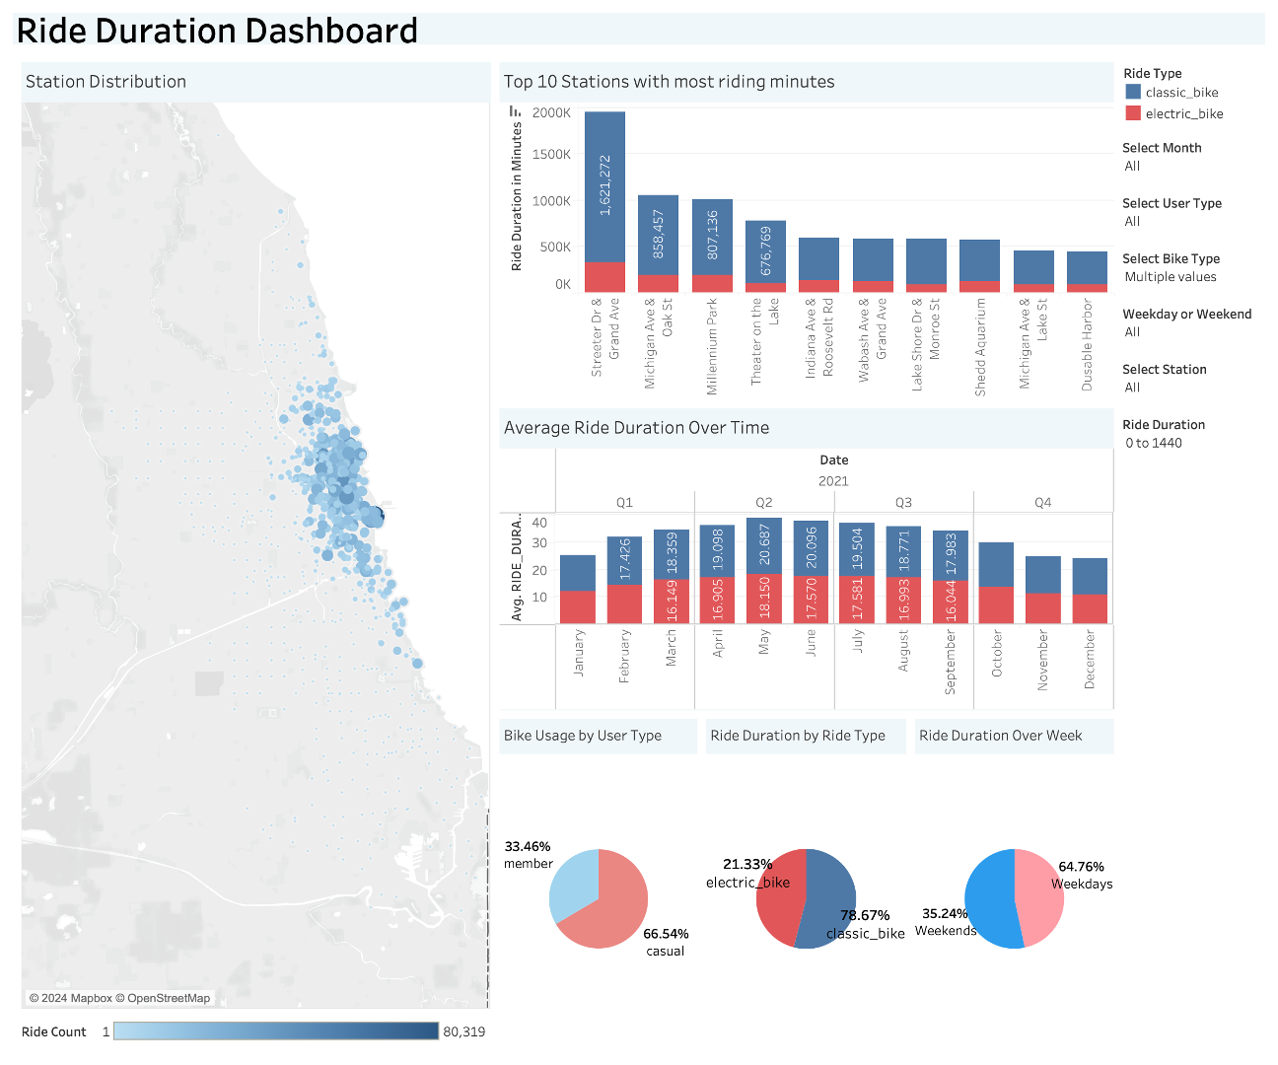

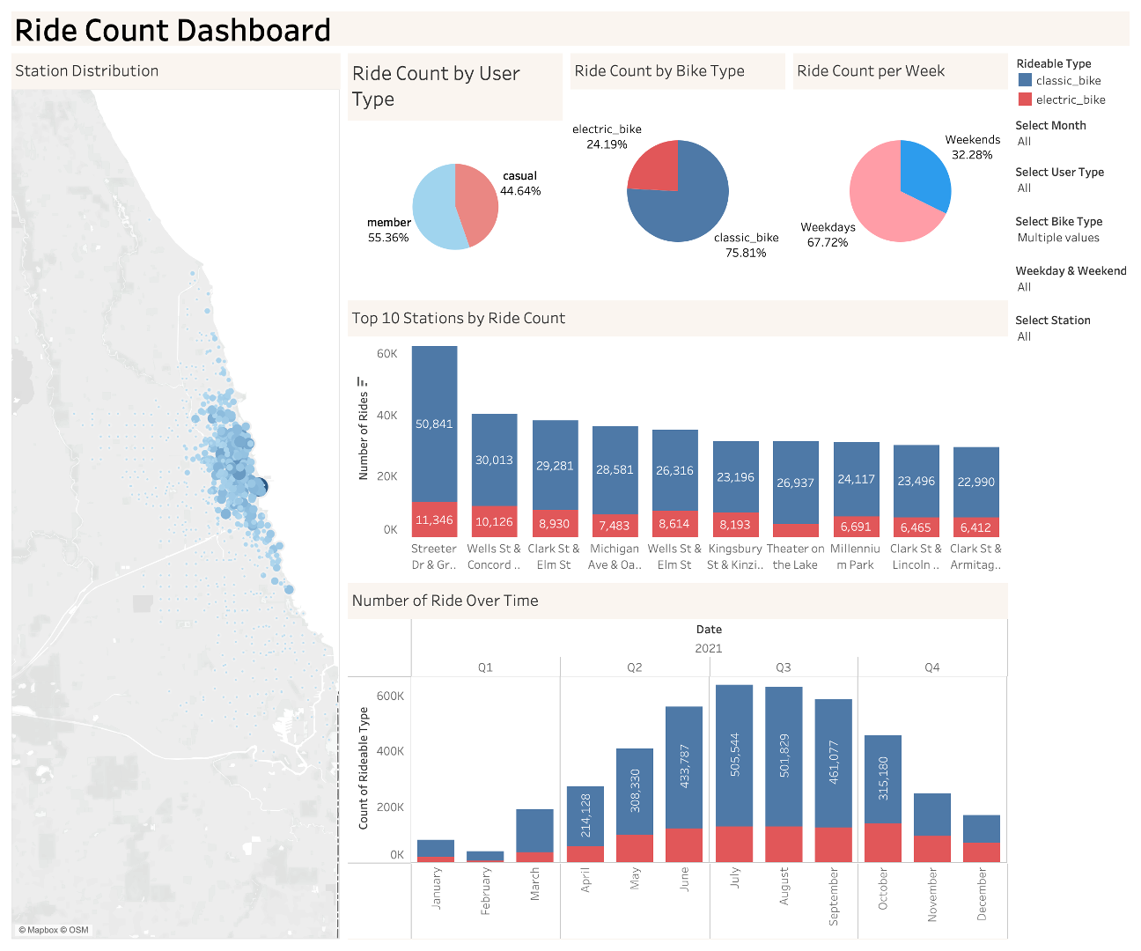

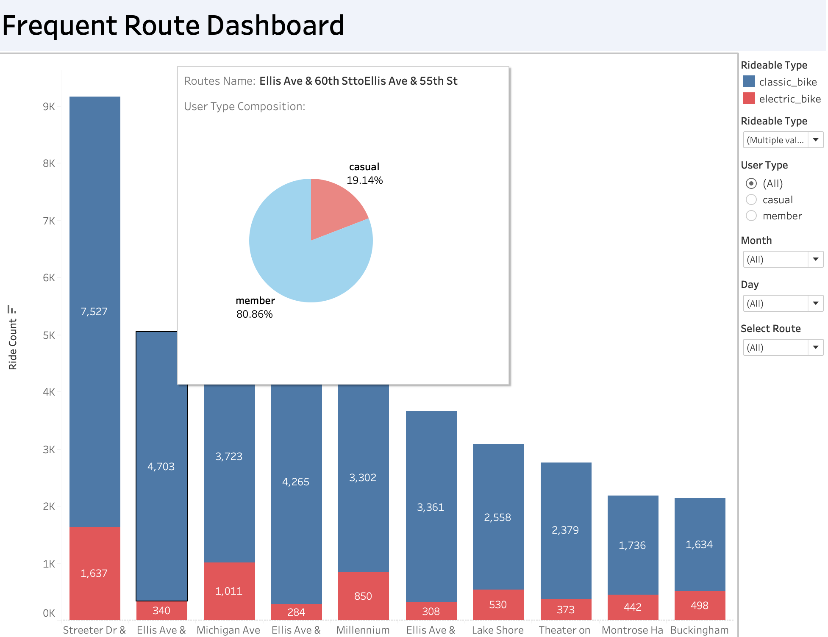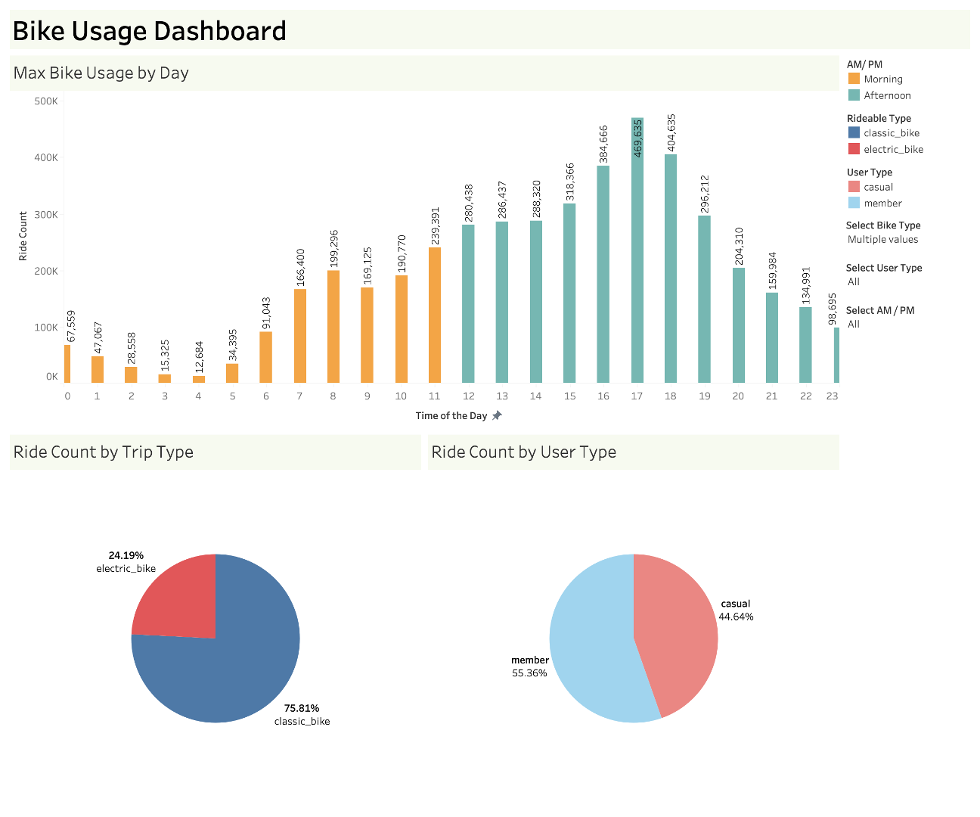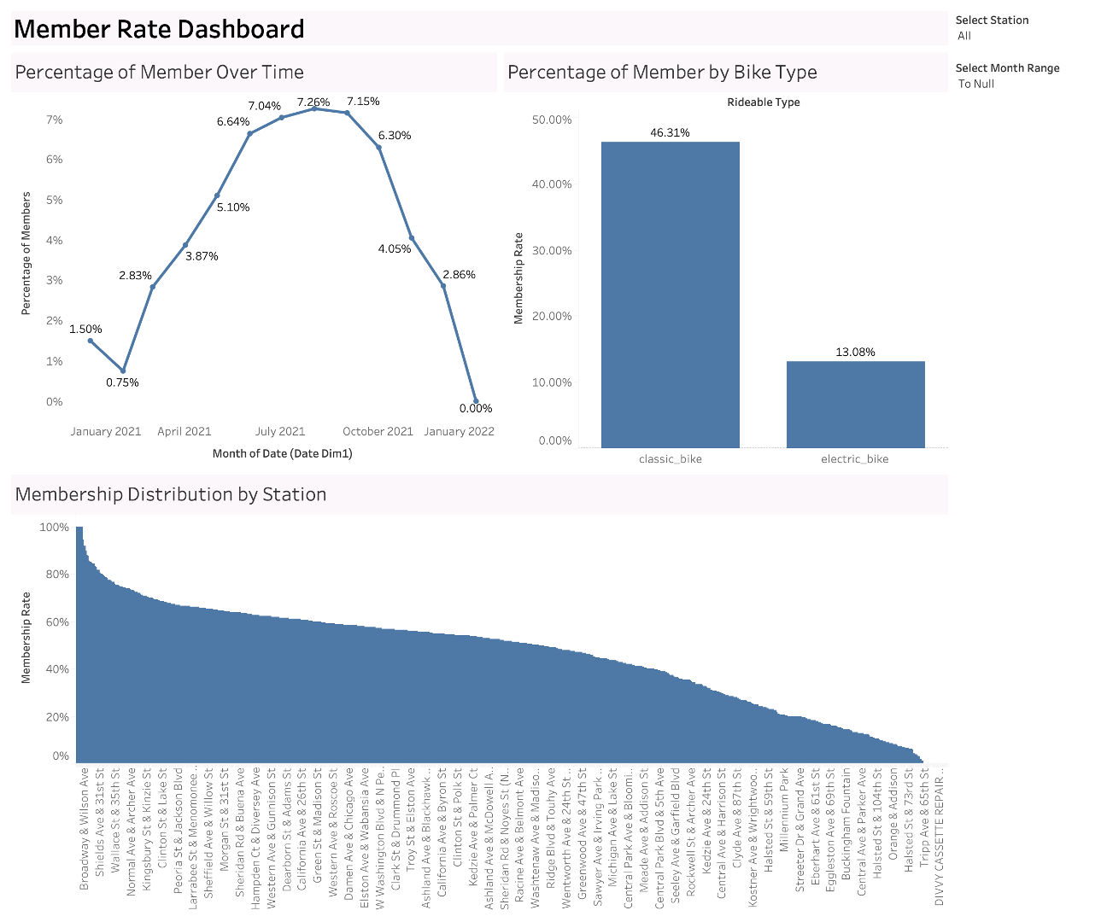

## Recommendations

During peak hours, there's a notable decrease in casual bike member rates, indicating that casual users face accessibility challenges, and addressing this by increasing bike availability could potentially boost market shares. This trend is particularly evident during rush hours at 6:00 AM and 5:00 PM, suggesting a significant drop in casual usage at these times. In contrast, weekends witness a higher casual member rate than weekdays, likely due to reduced accessibility for casual users during the busier workdays. Interestingly, there's a seasonal pattern in casual member rates, with a peak in July and a low in February, hinting at underlying factors affecting usage that merit further investigation. Evening rush hours see more bike usage, implying a variety of uses beyond morning commutes. For efficient operation, it's crucial to manage inventory effectively, ensuring an adequate supply of classic bikes and adapting electric bike distribution based on local demand. Finally, Divvy's focus should be on refining its products, particularly enhancing classic and electric bikes, and establishing strategic partnerships to improve bike storage facilities, especially where classic bikes are in high demand.

# Project Challenges

## Technical Challenges

As outlined in previous sections, we faced challenges in data sanity and integrity. The raw dataset contains a large number of missing values across station names, IDs, and geographic coordinates. While in theory, it might be possible to associate some missing station names or IDs with corresponding latitudes and longitudes, the dataset had certain inherent limitations that complicated this approach: 1. Geographic coordinates lacked precision, being accurate to only two decimal places and having a many-to-one relationship with station names and IDs; 2. The many-to-many relationship between station IDs and names resulted in non-unique identifiers. These constraints made the process of replacing missing values not only time-consuming and error-prone but also too demanding for our limited Snowflake capacity.

## KPI Calculations Challenges

The key challenges in KPI calculation stem from the vague definition of “docked bike”. Our team discovered that docked bikes have a significantly higher average ride duration, with multiple duration values above 24 hours. Since many docked bike trips have different start and end stations, we were unclear about the business process of docked bikes. Therefore, our team was unsure whether they should be counted as part of the analysis. Since the long trip duration from the docked bikes distorts the average trip duration, we decided to exclude the trips with an average duration above 1,500 minutes (25 hours).

# Further Research

The main drawback of the present research is that we lack a user information dataset and a bike information dataset so we can not conduct the user engagement and bike type profitability analysis necessary for profitability assessment. To make further decisions, the company should improve its records to include such information.

Suppose that such a requirement could be fulfilled, some interesting facts may be worth further notice and inquiries:

1. Monthly Differences in Bike Casual Member Rate: the evolution of casual member rates in different months is so smooth that there must be causal factors that lead to such results. A further study on this may help us better understand the periodical member preference for bike usage and make catering decisions.
2. Docked Bike Usage: Dicked bike is the most unpopular type of bike in the three different bike types, especially no member users would like to use this kind of bike. The company may consider reducing the implementation of such types and switching to some more popular types. However, this decision should take the data on profitability as well as casual user preference into consideration.

## Market Trend Research

Since all the insights from this report are based on data from 2021, it is critical to adapt future strategic decisions to the evolving market trends. For example, there is a potential rise in demand from people who need to do daily commutes in future years, as many companies start to require return-to-office. This may drive a different trend in demand, thereby influencing the strategic decisions on resource management, marketing plans, and pricing strategies.

# Appendix

Checklist: [Data Management Final Project: Project 5 - Cyclist Data - Google Sheets](https://docs.google.com/spreadsheets/d/14m3CDpXbowfxvtcCfCBhyk6CT-acTLL4nnLzdkS0AFI/edit#gid=0)

**KPI Calculations**

1. Ride Durations

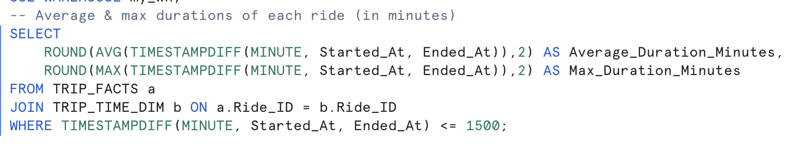

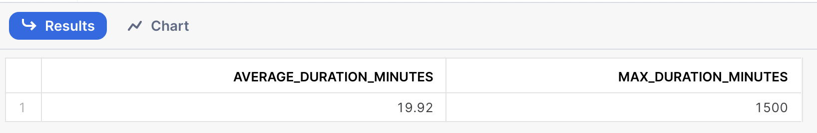

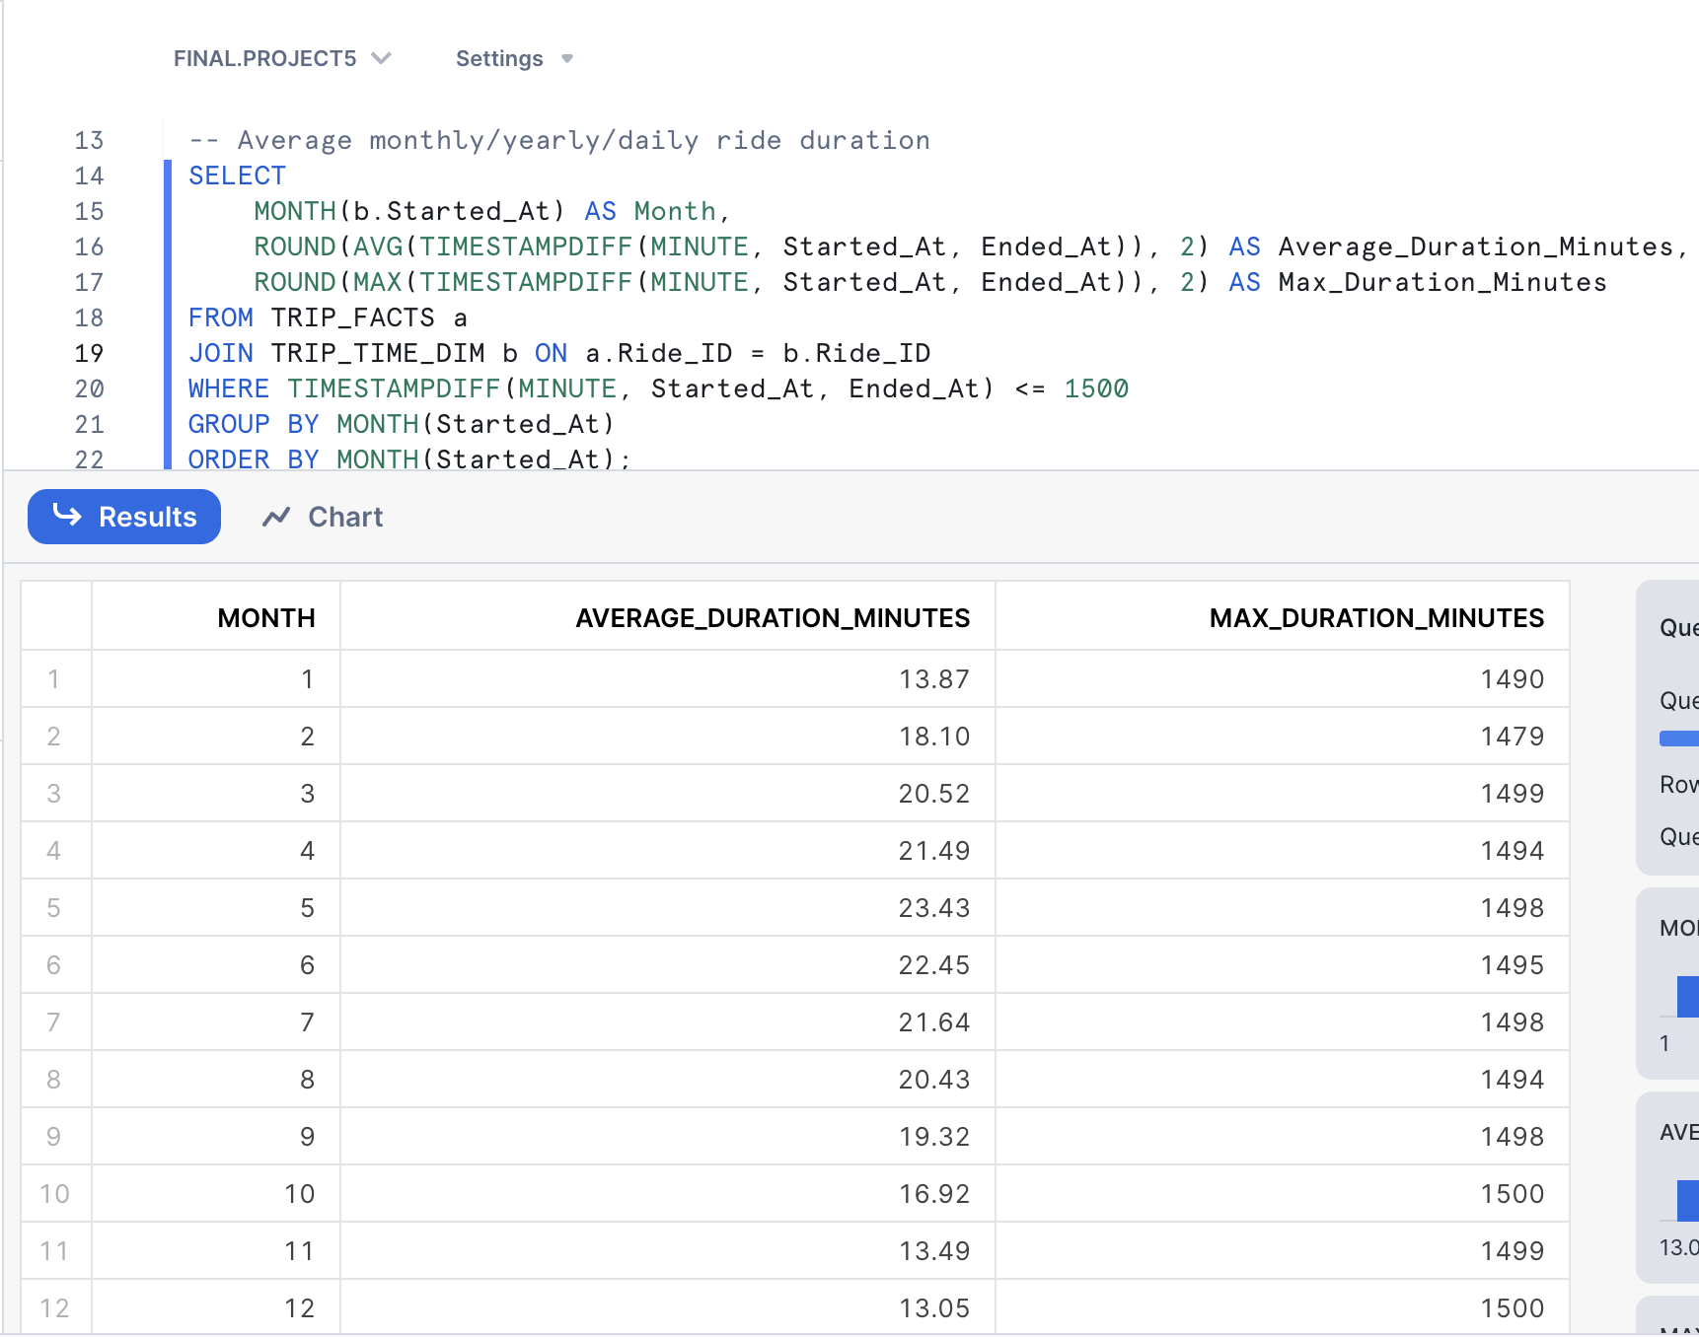

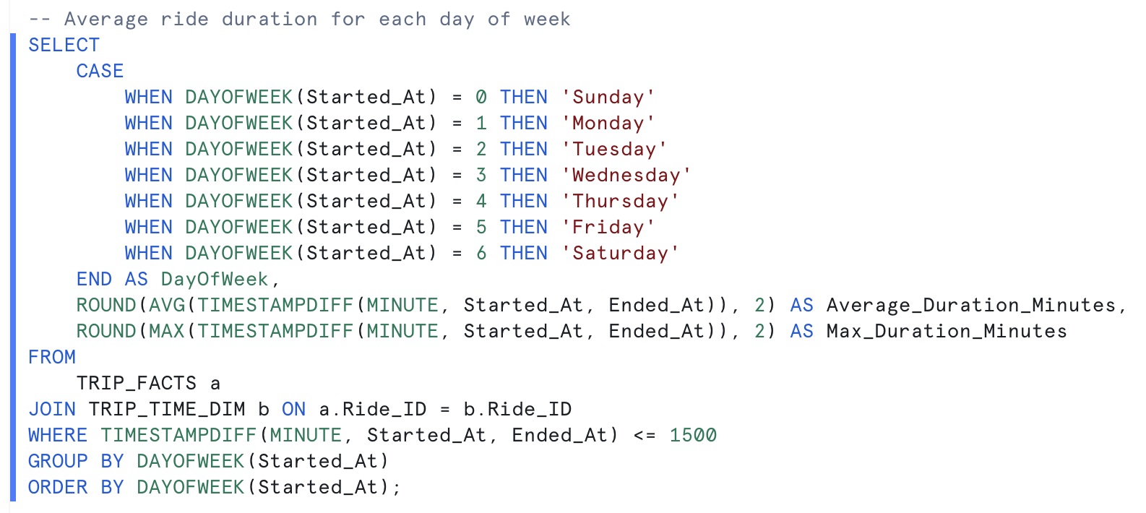

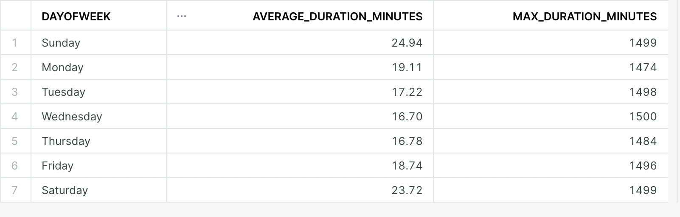

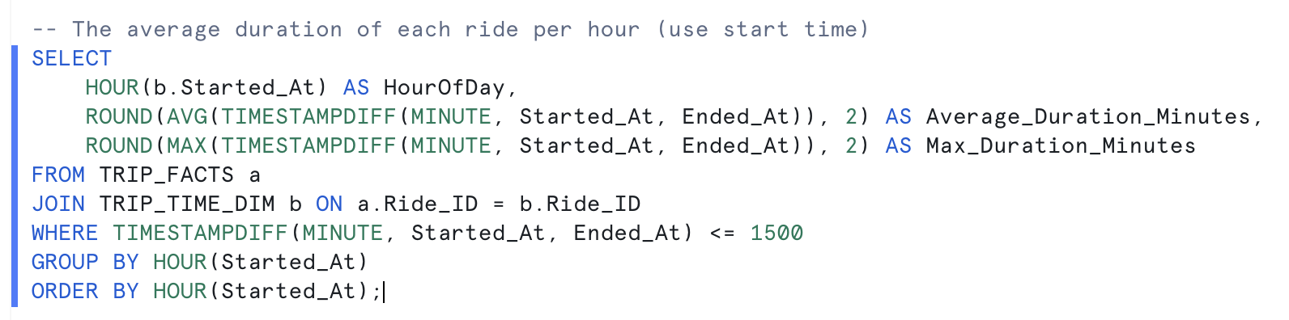

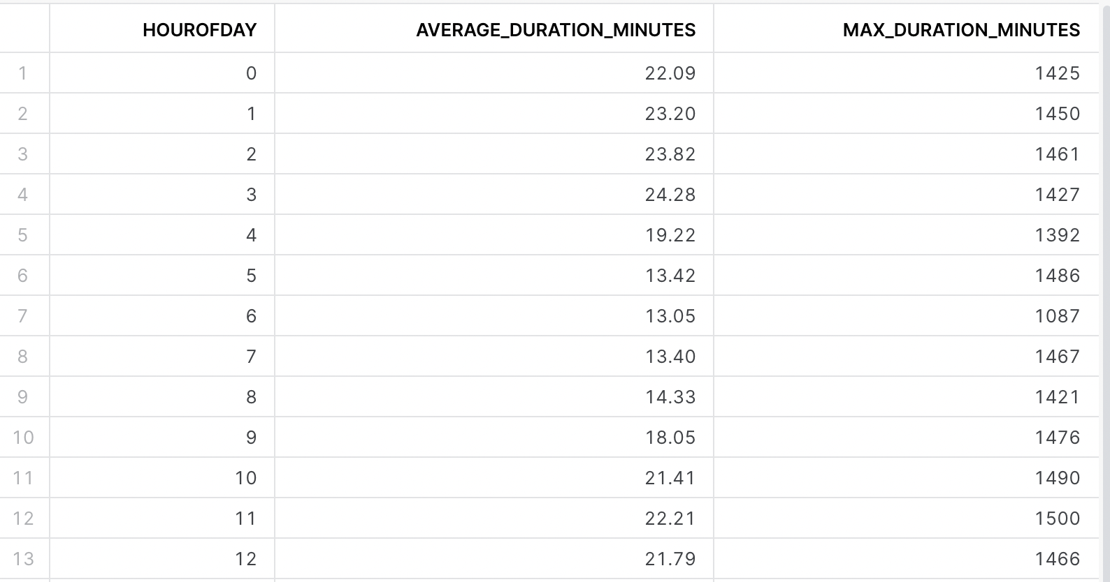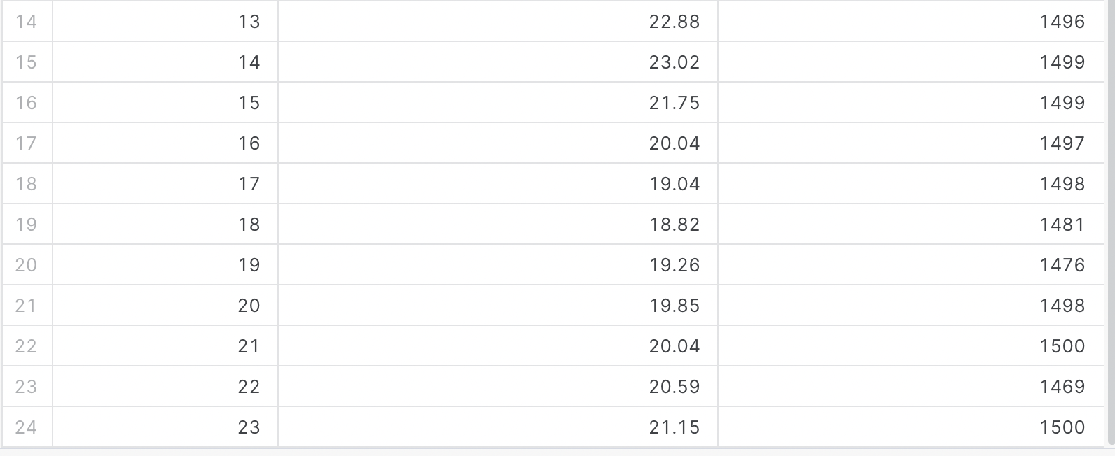

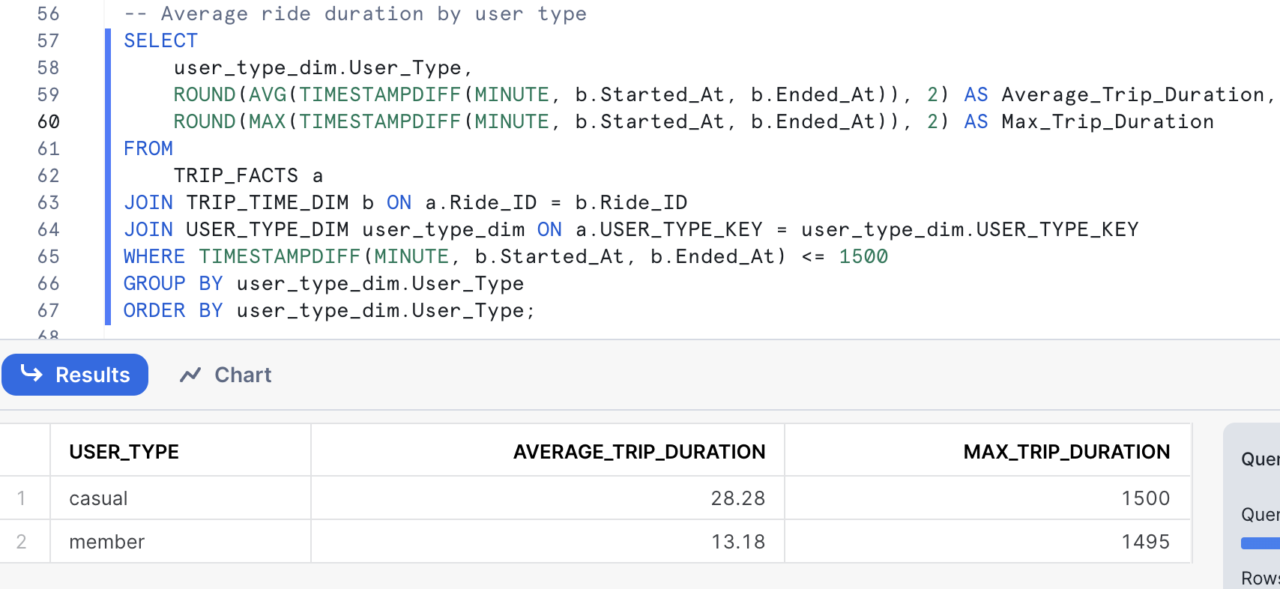

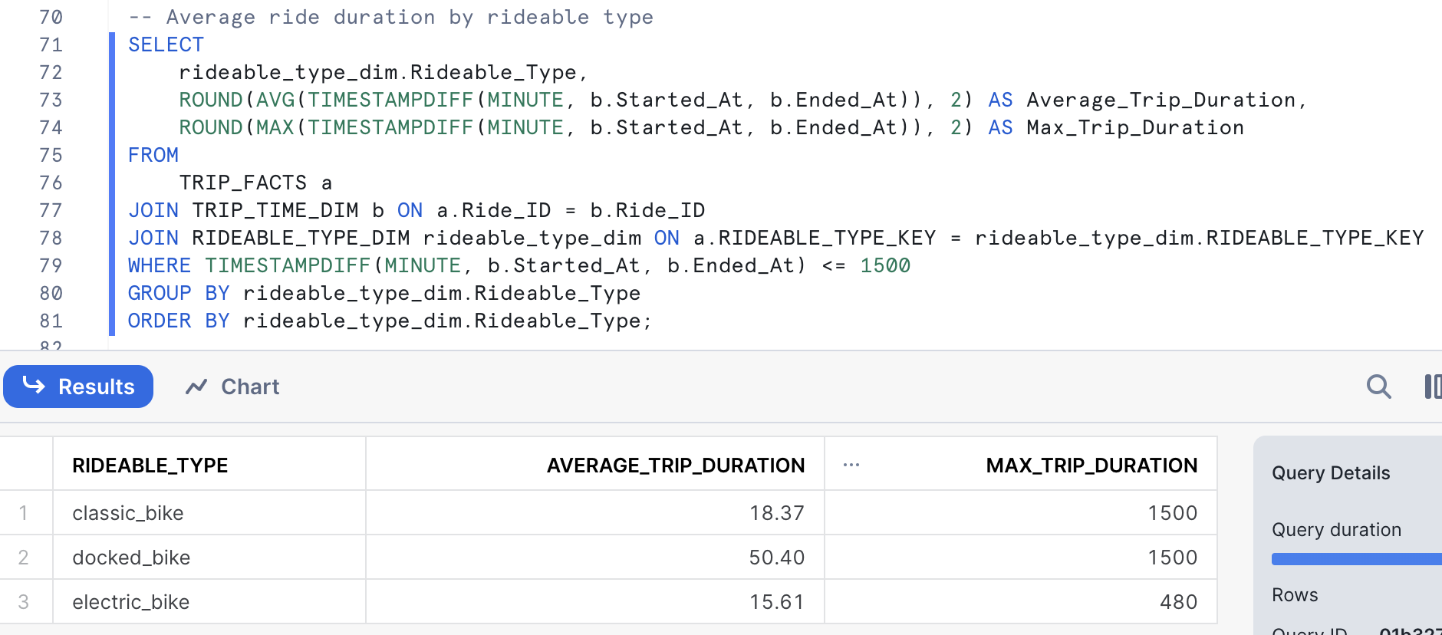

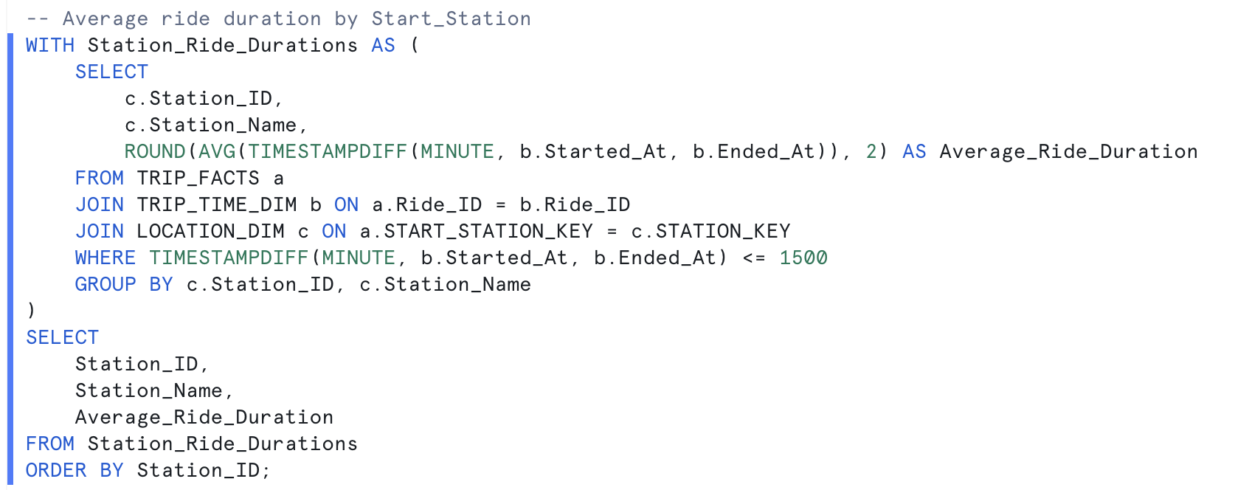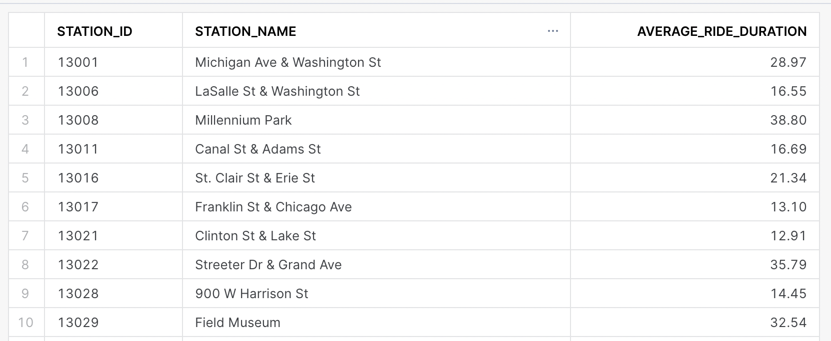

1. Most Common Rideable Type

